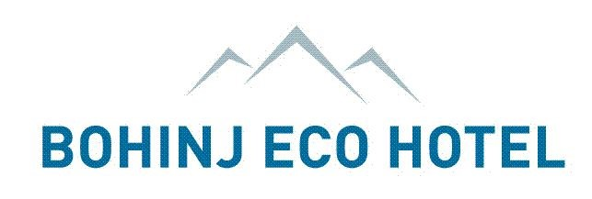

Leave nothing but footprints, take nothing but memories

ACCOMMODATION FORM FOR "THRIVE CONFERENCE 2020"
12 – 14 October 2020
Bohinj ECO Hotel, Bohinjska Bistrica, Slovenia
Please, fill in the form and send it to: ​mice@2864.si

Accommodation offer ​-​ All rates include VAT.

Bohinj ECO Hotel :
Double room/Twin room with separate beds: 100 € per room per night Double room for single use: 80 € per room per night

Price includes:
- accommodation and rich buffet breakfast
- unlimited access to the swimming pools in Aquapark
- Wi-fi
- parking lot in front of the hotel
- complimentary bottled water in room

Tourist tax: 2,50 € per person per night

Check-in at 14:00
Check-out until 11:00

Sunrose 7:
Double room: 125 € per room per night
Double room for single use: 110 €per room per night

(The Sunrose 7 does not hold twin rooms with separate beds, just classic double rooms.)

Tourist and service tax: 2,50 € per person per night

Price includes:
- Accommodation and breakfast
- Unlimited access to the swimming pools in Aquapark
- Wi-fi
- Parking lot in front of the hotel
- Bottled water in the room at arrival

Check-in from 14:00 on
Check-out until 11:00

Cancellation policy
From confirmation to 4 May 2020 the cancellation is free of charge.
From 5 May 2020 to 60 days before arrival we charge 20% of arrangement.
From 59 days to 20 days before arrival we charge 50 % of arrangement.
From 19 days to 7 days before arrival: we charge 60 % of arrangement.
From 6 days to 1 day before arrival: we charge 80% of arrangement.
No show: we charge 100 % of arrangement.

1

Leave nothing but footprints, take nothing but memories

Attendee:

Name and Surname: ___________________________________________
Phone: _______________________________________________
Contact e-mail: ___________________________________________________

Company: __________________________________________

Address of the company : ____________________________________________________________

City ____________________________ Country : _________________ VAT No: ________________

Date of arrival:​ __________________

Date of departure: ​_____________________

Please, mark the choice of hotel:
- Bohinj ECO Hotel
- Sunrose 7

I would like to book:
- a single room
- a twin room
- a double room

Please, provide the name of your room mate if you share a room.

________________________________________________________________

For the final room confirmation, we need a 100% bank transfer or credit card details.
I wish to pay / Želim plačati:
- By bank transfer
- By credit card

Shuttle​:
For airport transfer to the hotel we will be more than happy to assist you with the offer. Do you need a transfer offer:
- Yes
- No

Special request or dietary requirements

___________________________________________________________________________________________

2

